NOVEL IDEAS FIND SUCCESS AT INAUGURAL CANGIALOSI BUSINESS INNOVATION COMPETITION

On Thursday, April 24th, a full house of supporters turned out for the inaugural Cangialosi Business Innovation Competition (CBIC). Coordinated by UMBC’s Alex. Brown Center for Entrepreneurship, and made possible by a generous gift from alumnus and serial entrepreneur Greg Cangialosi, the CBIC offers students an opportunity to experience the process of planning a start-up business.

As the members of the teams arrived, a blend of confidence and nervousness filled the air. Eight (8) teams were selected out of 29 applicants to share their business ideas with a panel of three judges, John Cammack, Hugh Evans and Vince Talbert, all successful entrepreneurs and members of the angel investment group The Baltimore Angels. Teams were comprised primarily of UMBC undergraduate and graduate students, and each was paired with a business mentor to help them further develop and polish their idea prior to the final competition.

Stakes were high with cash awards of $5,000 for 1st place, $2,000 for second place, and $1,000 for 3rd place, as well as membership to Betamore, a Federal Hill based incubator and educational facility co-founded by Cangialosi.

First place went to Kyran Richardson and Percy Addo for their development of InSource, a web-based space that brings skills together with people. InSource helps students and faculty know what skills students have so finding a partner to work on a project, research, or company is easy and seamless. Richardson said the idea came about when he and his roommate were trying to find students on campus to collaborate on some business ideas they had, but due to a lack of connections they were unable to find the skills they required Knowing there is an abundance of talent around, they wanted to make the matching process easier in the future. When asked about the experience of participating in the CBIC, Richardson and Addo said they were “humbled by winning first place while competing against some of the most innovative students at UMBC.”

Second place went to Ethan Steininger for his company Compared Care whose mission is to make the healthcare world more transparent. There is a large geographical disparity within the healthcare industry and the same medical procedure will cost significantly more in one area vs another. ComparedCare.com will allow users to upload several variables to help them locate the best alternative. According to Steininger, “The CBIC was the ideal experience I needed to get started in entrepreneurship. It helped to validate my idea of Compared Care and placing second made it seem more legitimate. My mentor, UMBC alumus Andrew Pollack, was a perfect match and I will continue to communicate with him throughout this startup process.”

Third place went to Markus Protor and his team consisting of Walter Pearson, Kimberly Hodges, and Harjit Singh for their company, EduPal, which is working to revolutionize students’ study habits and improve planning by creating an online tool to help them manage their time more effectively. Markus commented, “Being a part of the CBIC was definitely an exciting and memorable experience. The atmosphere was amazingly positive and I enjoyed networking with some of the brightest entrepreneurs on campus and in the region. Having the opportunity to share my passion with students, faculty, and members of the Baltimore Angels was worth every hour of practice.”

Participation in the competition is just the first phase of the business education the winning teams will experience. By far the most important part of the CBIC will be what comes next, the involvement in Betamore programming and events which will provide valuable connections to the Baltimore business community.

Following the event Cangialosi said, “I am so proud of all the students who participated in the competition. It was exciting to see that innovation and the entrepreneurial spirit is running high at UMBC! I look forward to the next competition and taking it to the next level.”

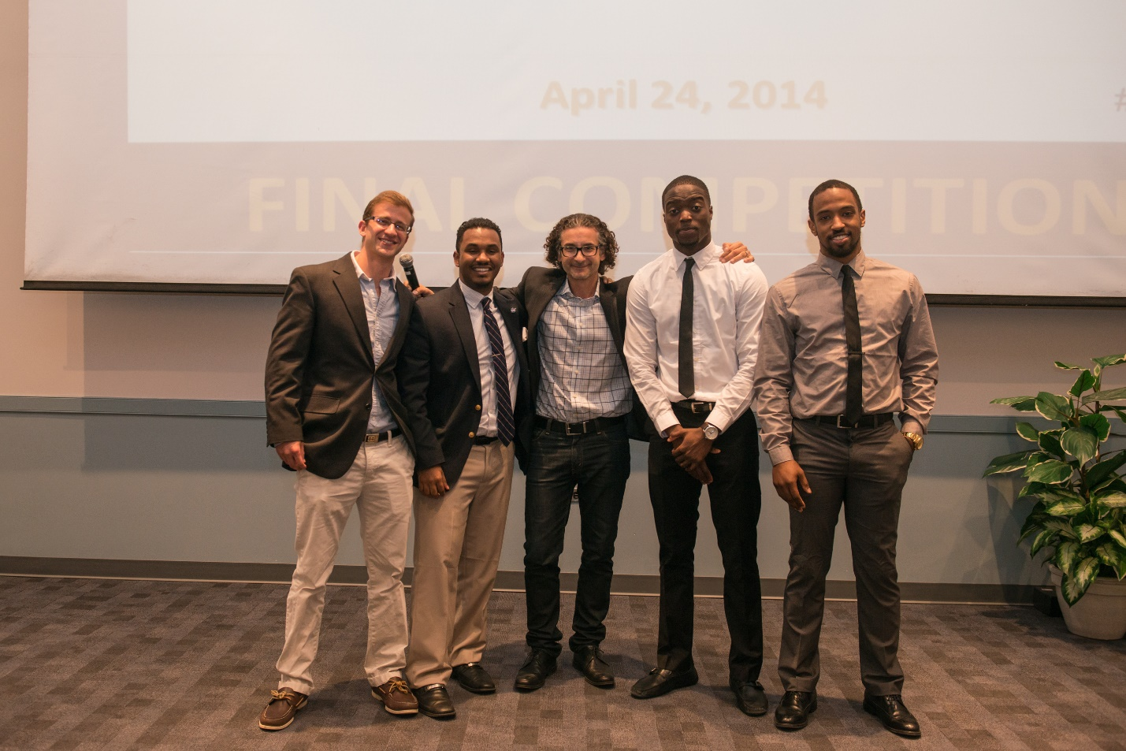
Picture of 2014 Winners. From left to right they are: Ethan Steinenger, Markus Proctor, Greg Cangialosi, Percy Addo, Kyran Richardson

